Assignment 1:

Output:

**Task 1:**

1. Install Jupyter notebook and run the first program and share the screenshot of the output.

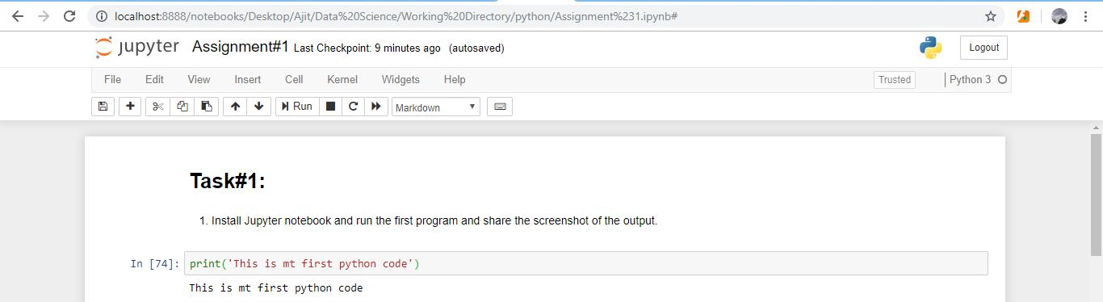

1. Write a program which will find all such numbers which are divisible by 7 but are not a multiple

of 5, between 2000 and 3200 (both included). The numbers obtained should be printed in a

comma-separated sequence on a single line.

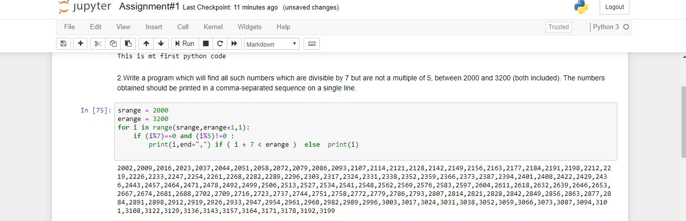

1. Write a Python program to accept the user's first and last name and then getting them printed in

the the reverse order with a space between first name and last name.

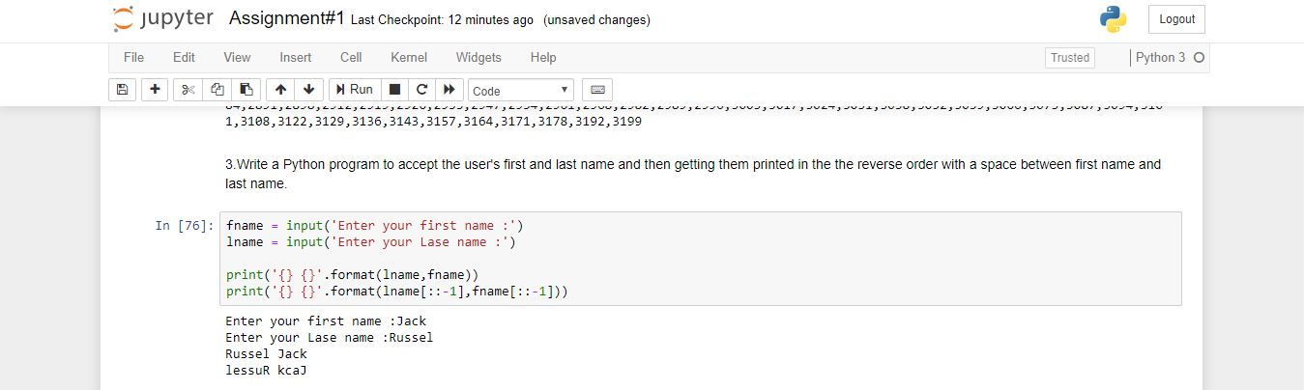

4 ; Write a Python program to find the volume of a sphere with diameter 12 cm.

Formula: V=4/3 * π * r 3

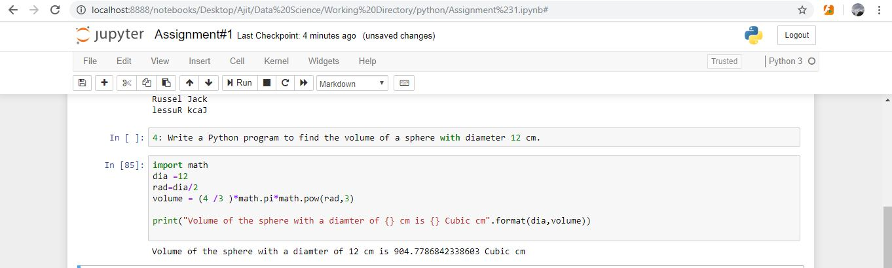

**Task 2:**

1; Write a program which accepts a sequence of comma-separated numbers from console and

generate a list.

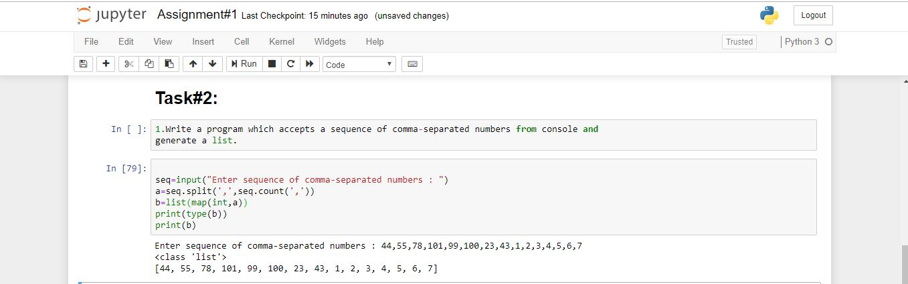

2: Create the below pattern using nested for loop in Python

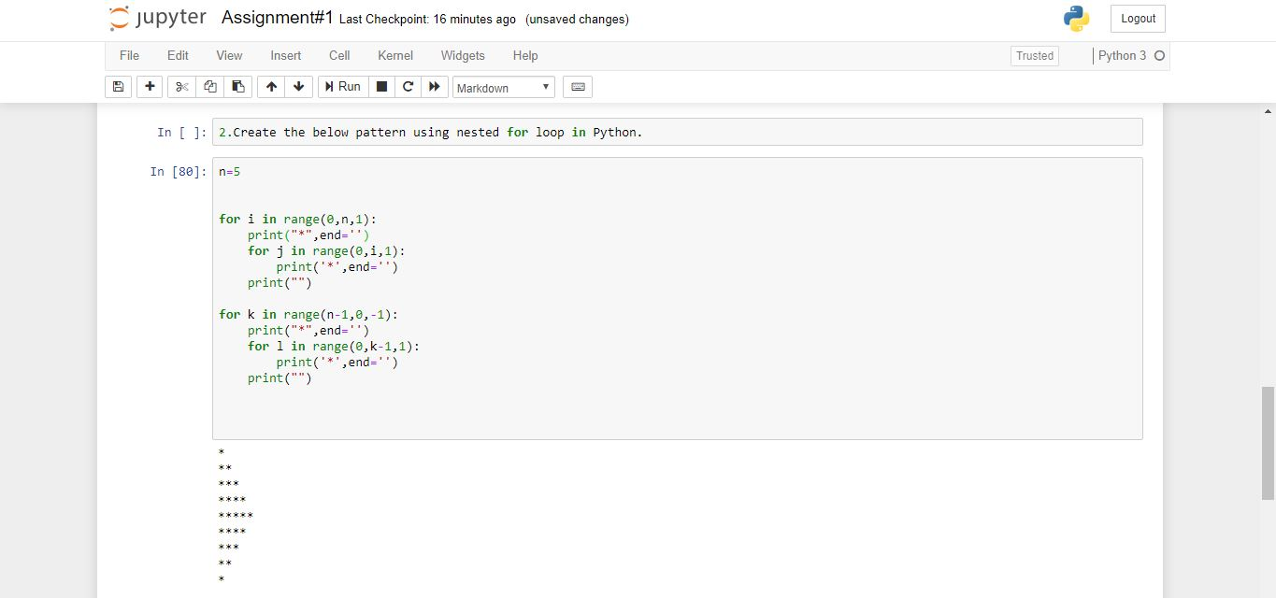

3: Write a Python program to reverse a word after accepting the input from the user

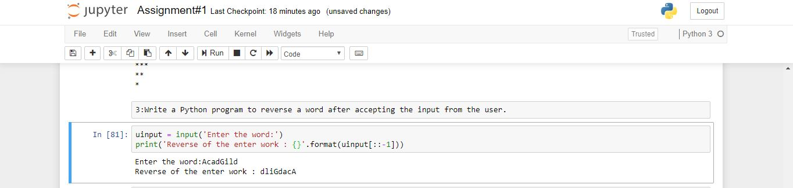

4 : Write a Python Program to print the given string in the format specified in the sample output.

